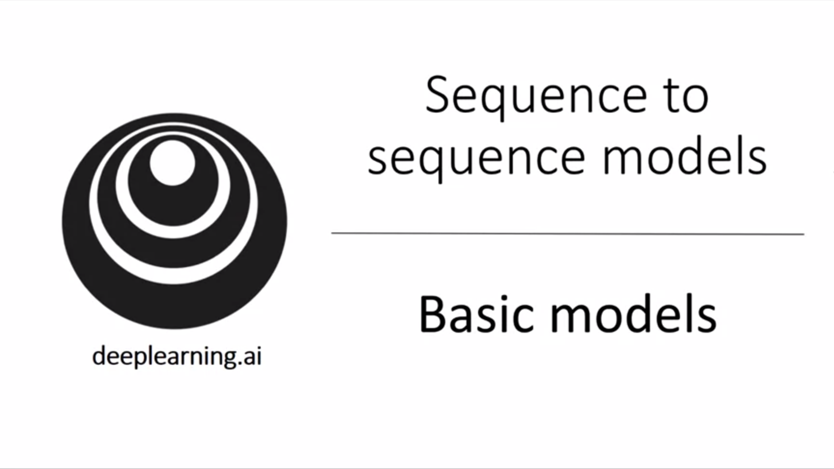

In this week we will look at sequence to sequence models which are useful for example for speech recognition and machine translation.

We will also hear about beam search, the attention model and how to synthesize audio data.

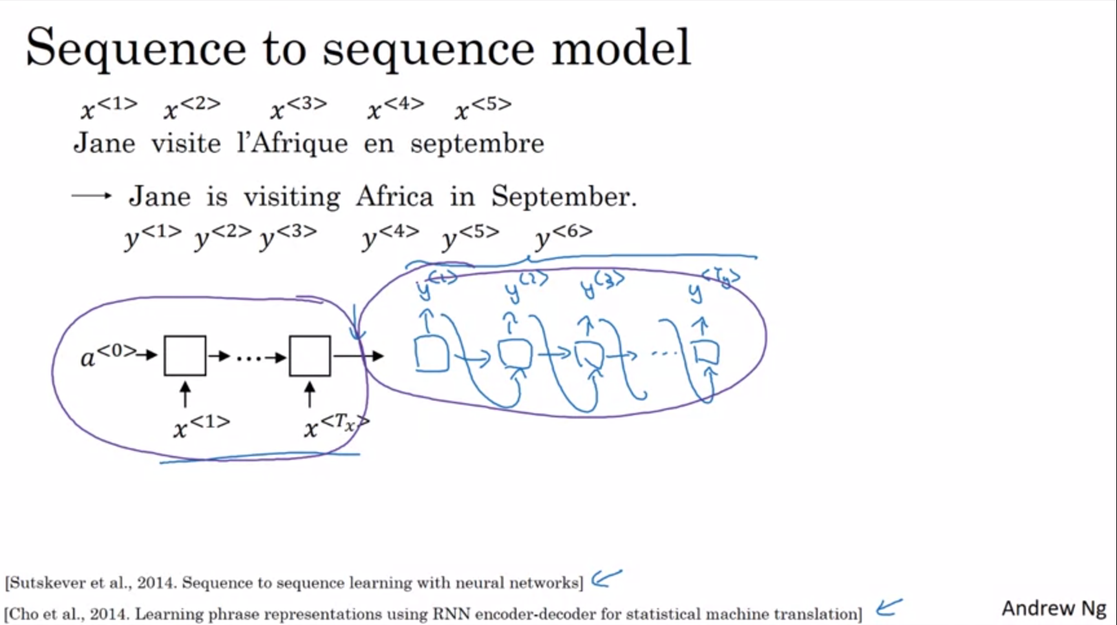

Example: translate French sentence (x) into English sentence (y).

The idea presented here is due to the papers on the slide.

We have an encoder network (could be standard RNN, GRU or LSTM) which outputs a vector after having seen the entire input. Then we have a decoder network which takes this vector as input and will output the translation one word at a time until eventually it outputs the <EOS> token. The previous outputted words will go as well as input into the subsequent word prediction. One of the remarkable results is that this models works very well.

Given enough pairs of sentences we can train a model like this.

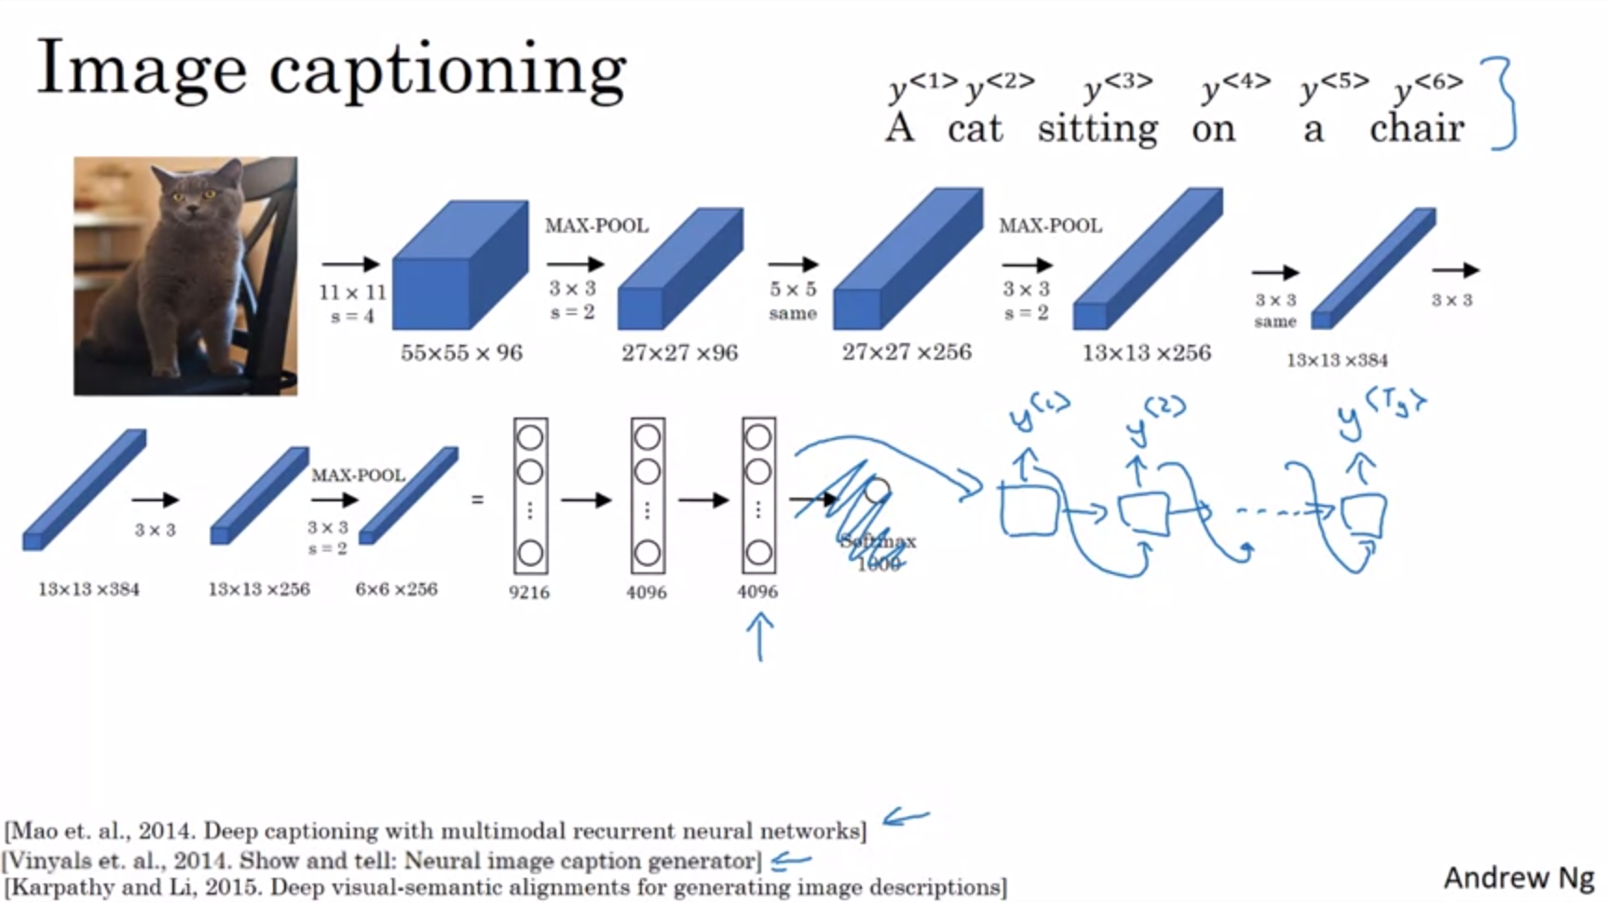

An architecture very similar to this also works for image captioning.

In image captioning we have an image as input and want to output an image caption.

First, we have a CNN to learn an encoding / set of features, e.g. pretrained AlexNet (without final softmax unit). This would be an encoder. We then take the resulting vector and feed it into an RNN whose job it is to generate the caption one word at a time (similar to what we have seen for machine translation). This works pretty well for image captioning.

This type of models was proposed by the papers on the slide independently at about the same time.

We have now seen a basic sequence to sequence or image to sequence model.

There is some difference between this and a language model to synthesize novel text. Now we do not want a randomly chosen translation but we want the most likely translation (similar for caption).

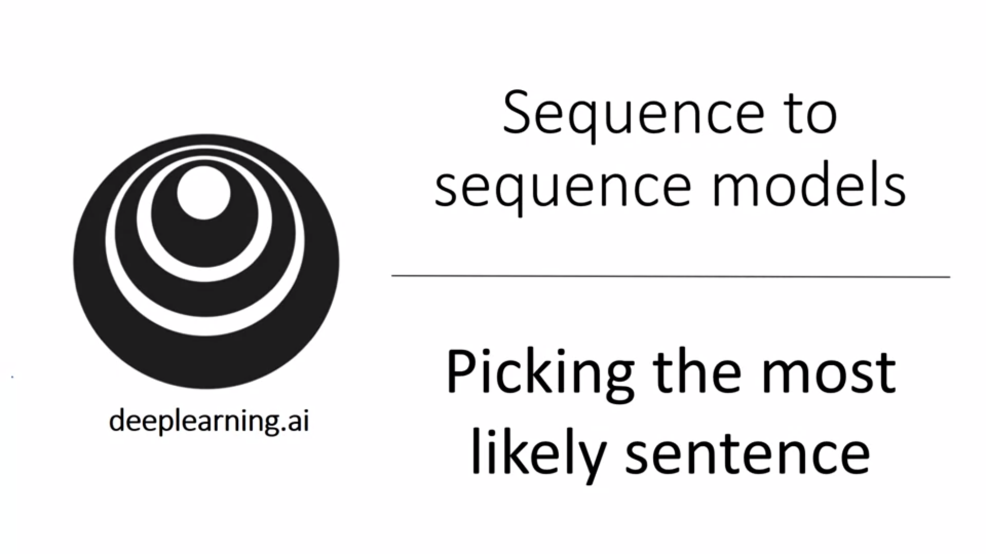

How to generate the most likely translation / caption?

There is some similarity between the sequence to sequence machine translation model and the language models that we have worked with previously. But there are some significant differences as well.

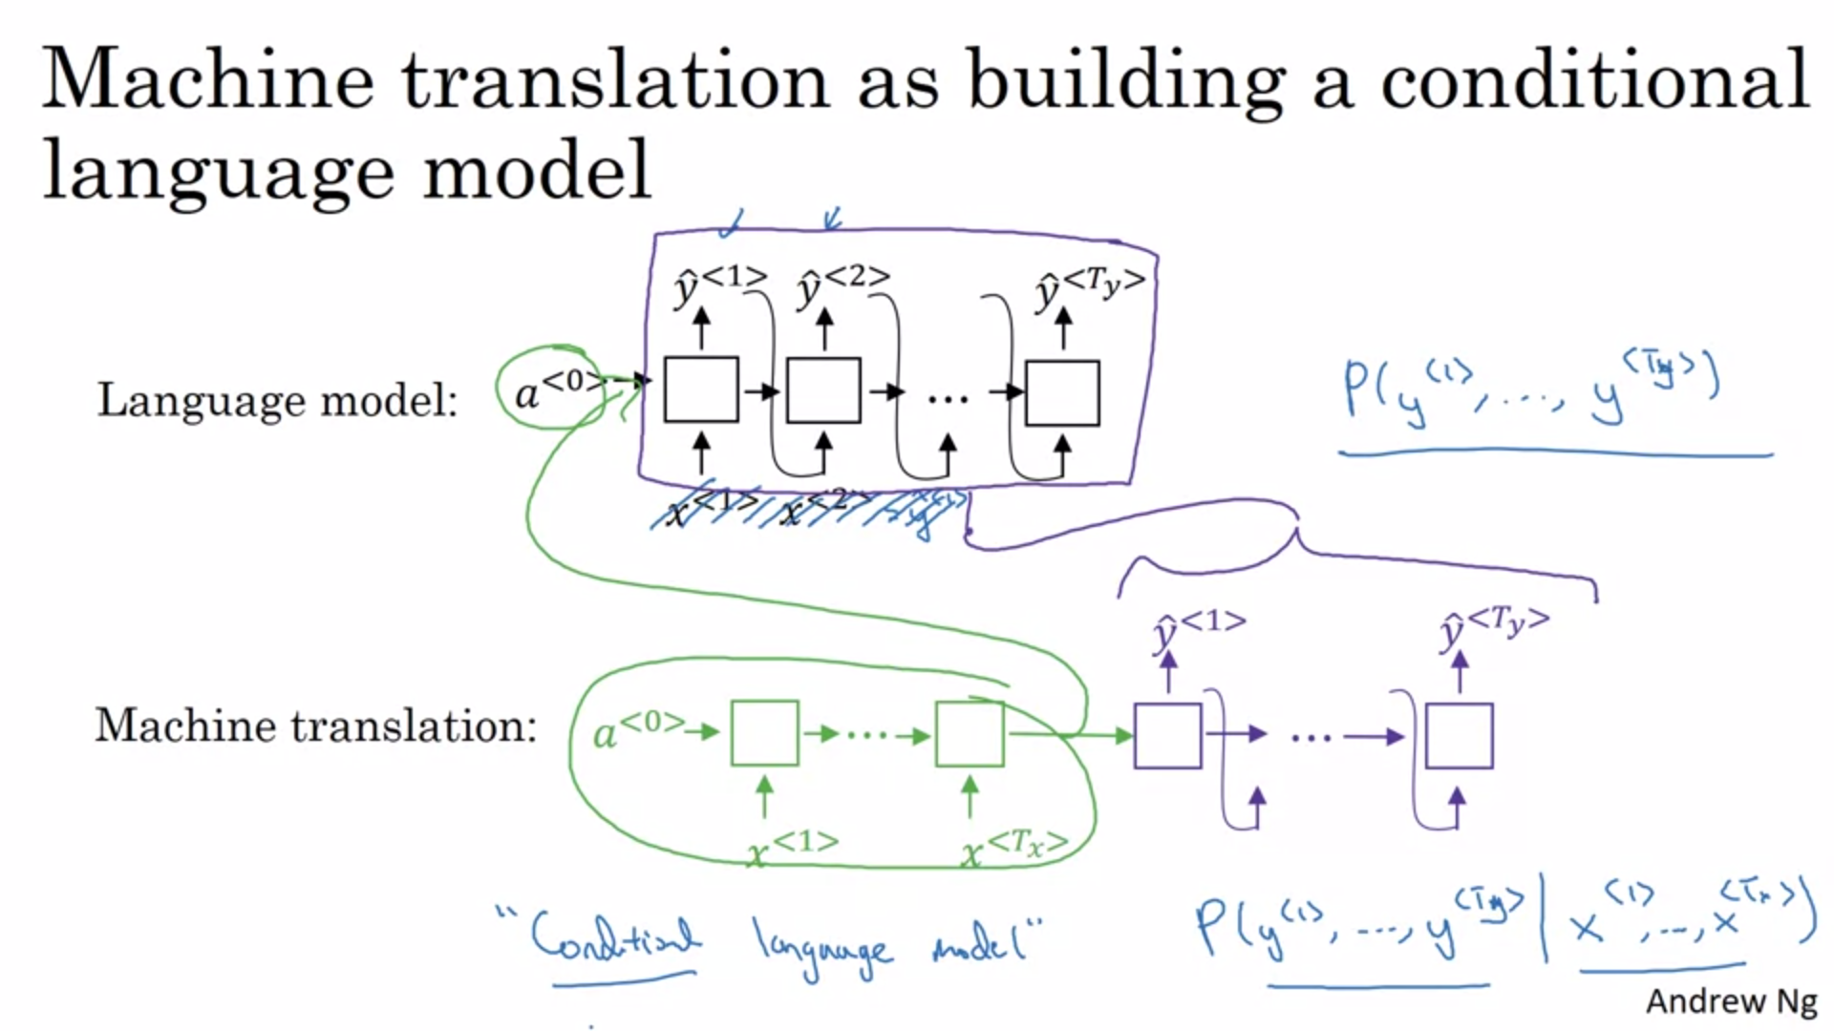

Think of a machine translation model as a conditional language model.

With the language model we estimated the probability of a sentence. This was used to generate novel sentences. There was no input x.

For machine translation we have an encoder network (green) and a decoder network (purple). The decoder network looks very similar to the language model but instead of starting off with a vector of 0s we have an encoder network that figures out some representation for the input sentence. Andrew calls this a conditional language model. We are now modeling the probability of the output English translation conditioned on some French input sentence.

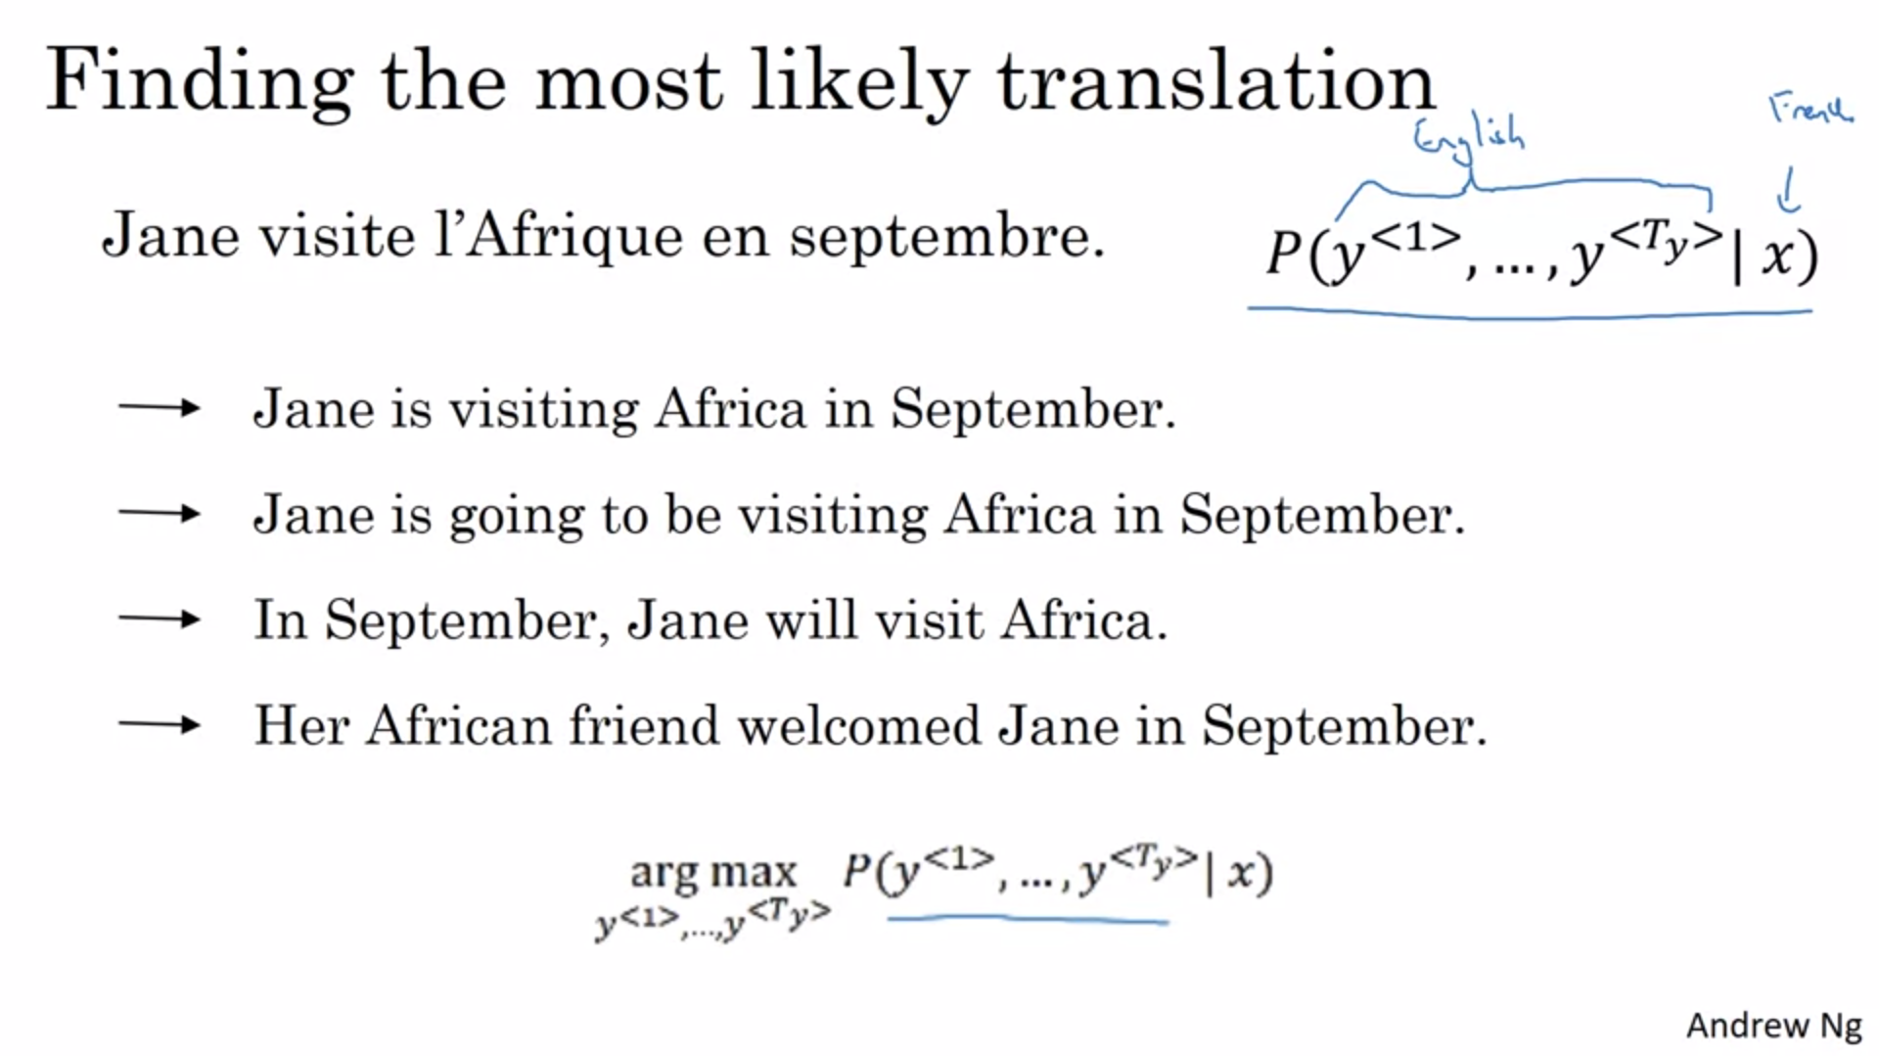

Instead of sampling randomly from the probability distribution like in language models, we now want to maximize the conditioned probability. Random sampling would lead to good translations sometimes but sometimes to bad translations (examples on slide).

The algorithm should find the value of y that maximizes the probability. An algorithm that can do this is beam search which we will see now.

Before moving on to beam search, why not greedy search?

Greedy search would mean to pick the most likely word before moving on to the next word.

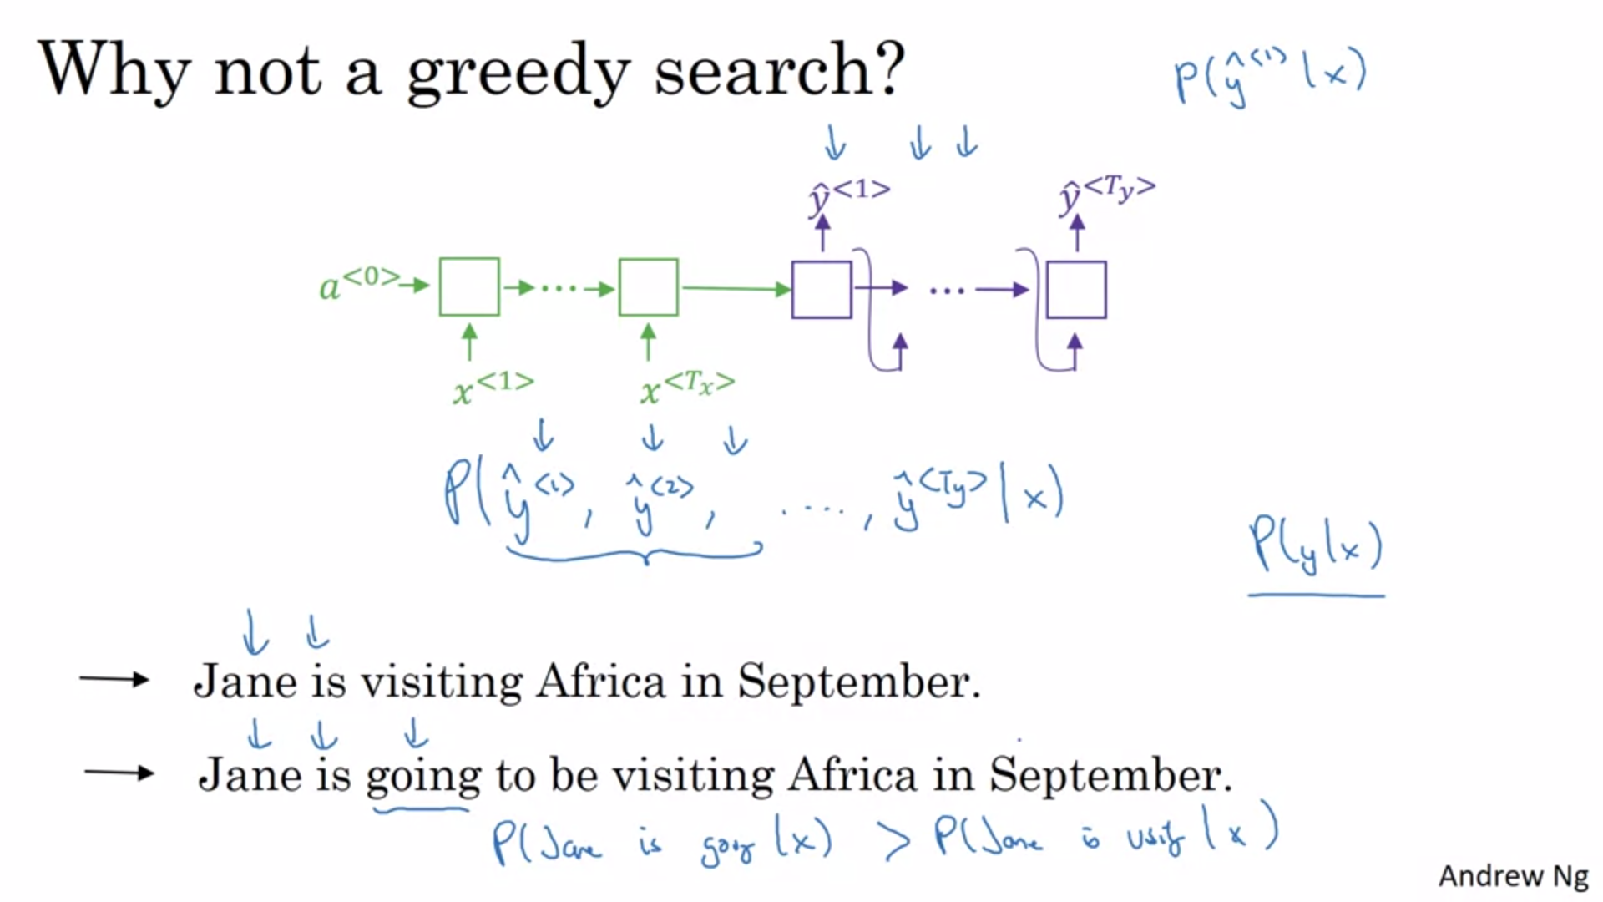

It is not always optimal to pick one word at a time. What we would really like is to pick the entire sequence of words that maximizes the joint probability. The greedy search approach on a word-by-word basis will not work for this objective.

Example: going is a much more likely word than visiting and will therefore be picked as a third word. But this will ultimately end up in a less optimal sentence.

Of course the total number of combinations of words in an English sentence is exponentially large. E.g. vocabulary size of 10k with a sentence of length 10 will lead to 10k^10 possible sentences.

This is a huge space of possible sentences. It is not tractible to exhaustively enumerate and calculate the joint probabilities for all possible combinations of words. We use an approximative search algorithm instead. It will try to pick the sentence y that maximizes the conditional probability. This is not guaranteed but usually approx. algorithms do a good job.

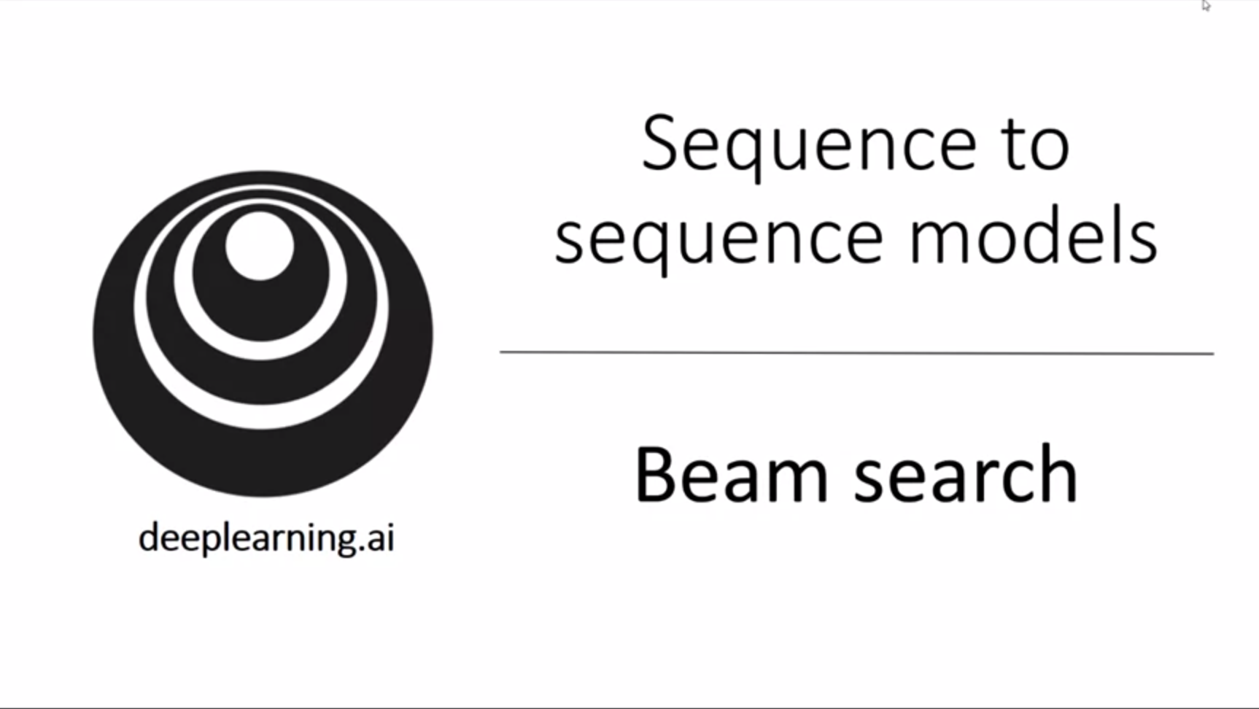

Now we will learn about the beam search algorithm which can help with outputting the most likely translation / transcript / caption. It is the most widely used algorithm to do this.

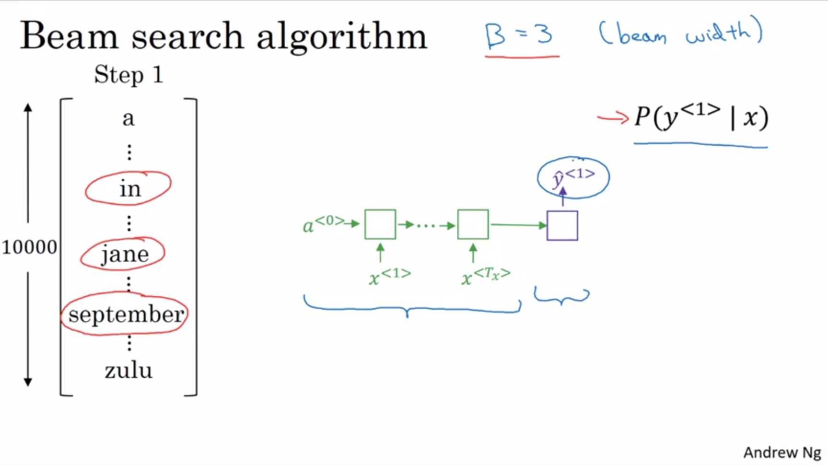

First step of beam search: pick the first English word to output (out of the vocabulary). Whereas greedy search will pick only the one most likely word, beam search can consider multiple alternatives based on parameter B (here 3 at a time).

Beam search will store in computer memory that it wants to try out all 3 most likely choices for a first word.

If the beam width parameter would be 10 instead of 3 it would keep track of the 10 most likely choices.

In order to do the first step of beam search we first need to run the input French sentence through the encoder and then keep in memory the top 3 outputs of the first decoder step based on softmax output.

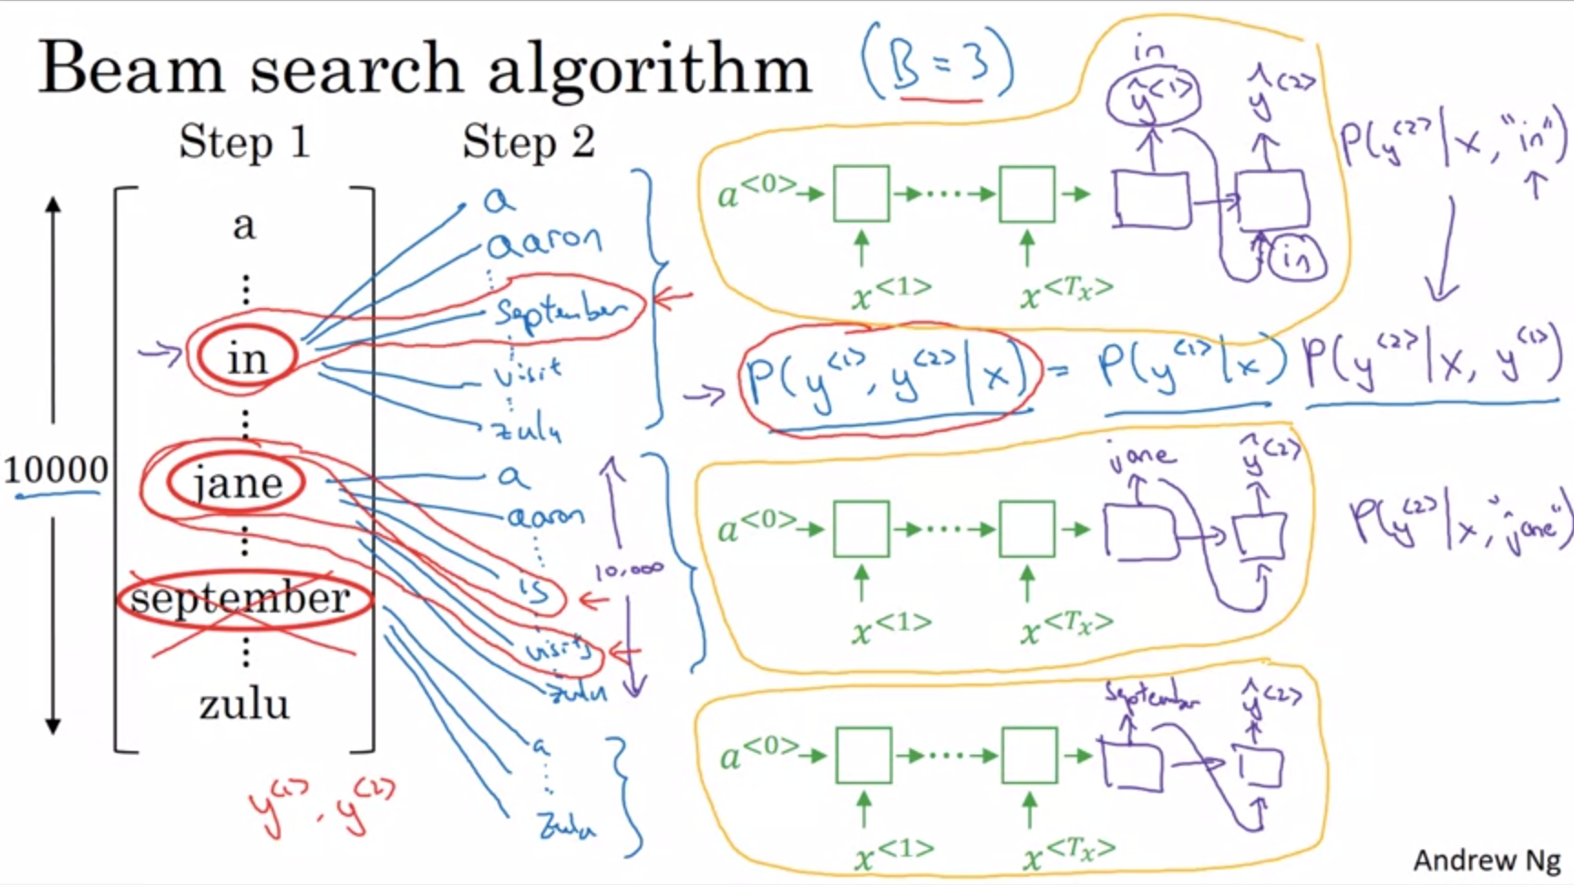

For the second step, beam search will now do the same for each of these three choices.

The neural network fragment that is relevant will now be the orange part (the decoder portion now has 2 outputs). Since we decided for “in” to be the first output that is the word that will be fed into the second piece of the decoder. We are hardwiring y_hat<1>.

What we care about at this step now is the pair of 2 words that is the most likely. By the rules of conditional probability this can be expressed as shown on slide -> probability of first word given input sequence times probability of second word given the input sequence and the first word.

We do the same for “jane” and “september” over all 10k words in the vocabulary.

For beam width of 3, you have 3 copys of the network to evaluate these partial sentence fragments. With this you will evaluate all 30000 possibilities (10k softmax outputs for each copy). We then cut it down to 3 again, e.g. “in September”, “jane is”, “jane visits”. The beam search algorithm would now reject “September” as a candidate for the first word.

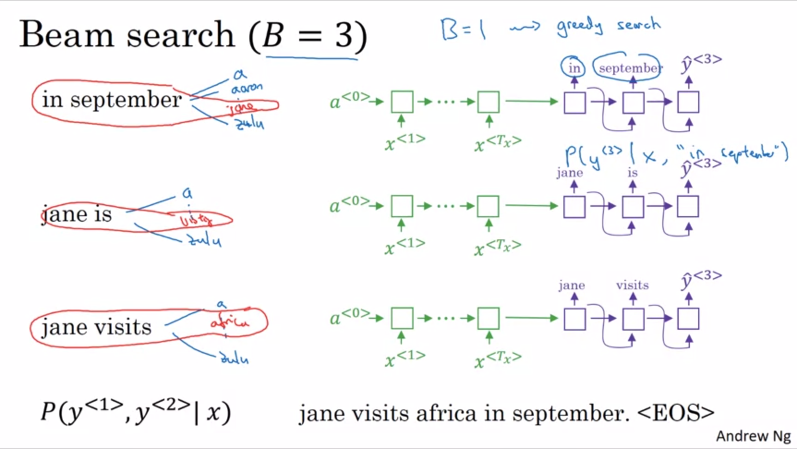

One more step of beam search: what is the third word? Now we use a bigger network fragment with 2 given outputs. Beam search will pick the top 3 likely combinations again.

The outcome of this whole beam search process will hopefully be the entire sentence with maximum likelihood (very high likelihood).

If the beam width is set to be equal to 1 this becomes the greedy search algorithm.

Beam search will usually find a much better output sentence than greedy search.

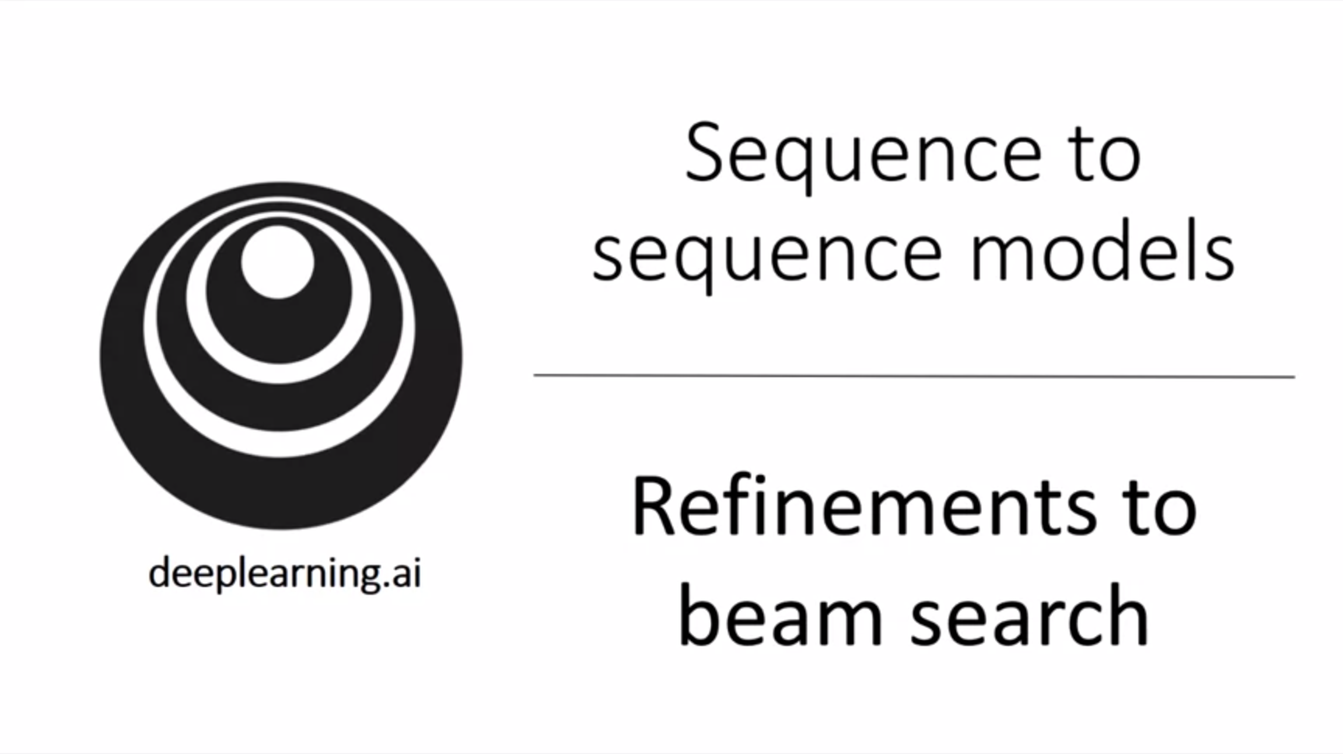 There are some additional tips & tricks to help us make beam search better.

In the last video we have seen the basic beam search algorithm.

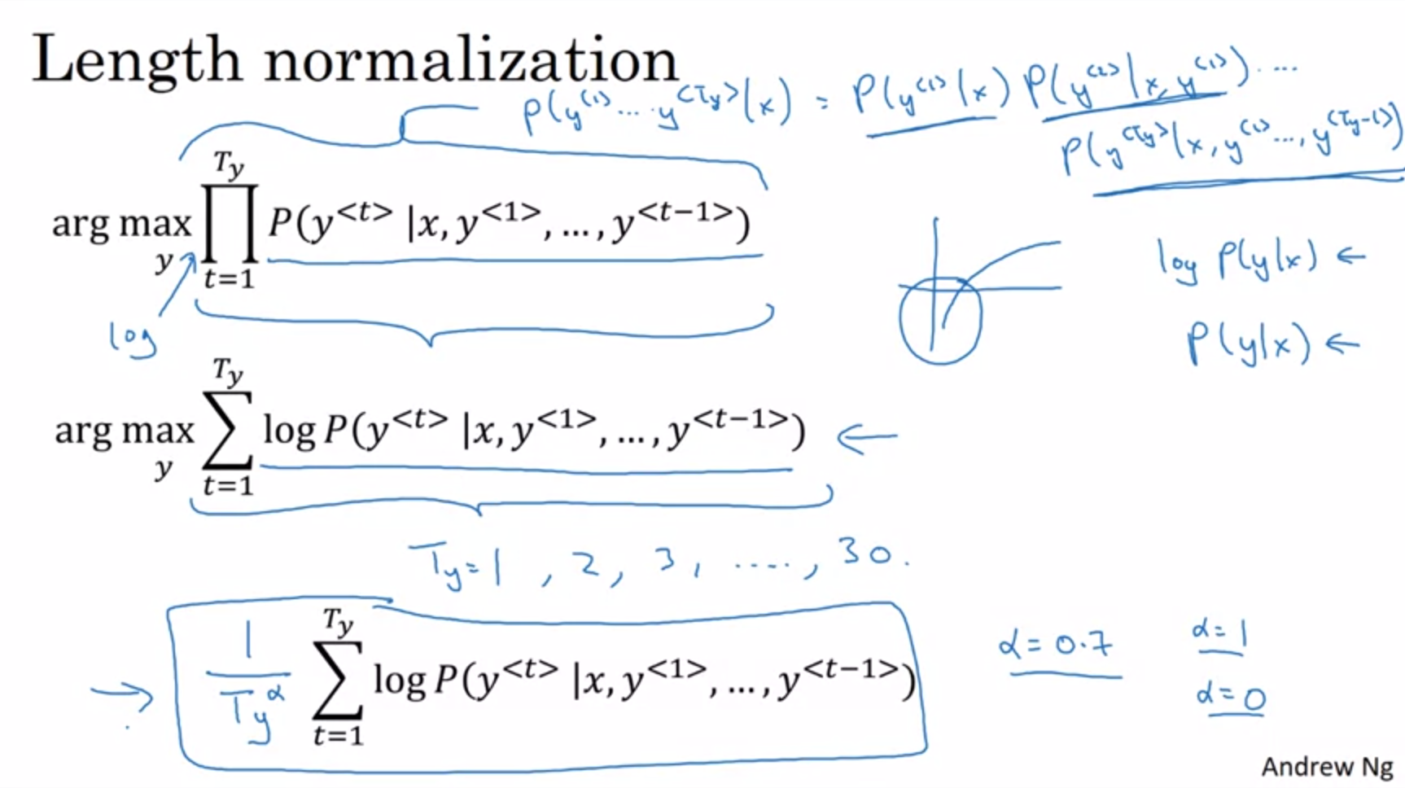

Length normalization is a small change that can help get much better results.

We talked about beam search maximizing above probability (product of probabilities). All these numbers are much less than 1. Multiplying a lot of numbers less than 1 will result in a very tiny number that can result in numerical underflow. So instead in practice we take logs of the probabilities and sum them. This is numerically much more stable and less prone to rounding errors.

The log function is a strictly monotonically increasing function. So maximizing p(y|x) gives the same result as maximizing log p(y|x).

There is one more change to this objective function to make it work even better.

If you have a very long sentence the probability of this sentence will be low as you multiply a lot of numbers. That is why the undesirable effect is that the objective function will prefer very short sentences. The same applies for the log-converted objective function. We will be in the negative part of the log function and the more numbers are added together, the more negative the output will be.

That is why we change the objective function with the normalization factor 1/T_y (number of words in the translation). This takes the average probability and significantly decreases the penalty for outputting longer sentences. In practice we use the softer approach with 1/(T_y^alpha) where alpha is e.g. 0.7. So we are not doing complete normalization. This is somewhere in between doing full normalization and no normalization.

Alpha is a hyperparameter of the algorithm that can be tuned. Using alpha this way is a heuristic. There is no real theoretical justification for this.

When you run beam search you will get a lot of sentences with length equal 1,2,3. Maybe you run beam search for 30 steps so you will get output up to a length with 30.

With beam width of 3 we will keep track of the top 3 possibilities for each of these sentence lengths. Then we would look at all the output sentences and score them with this objective function. Finally, we pick the one sentence that achieves the highest value on this normalized log probability objective. That would be the final translation that we output.

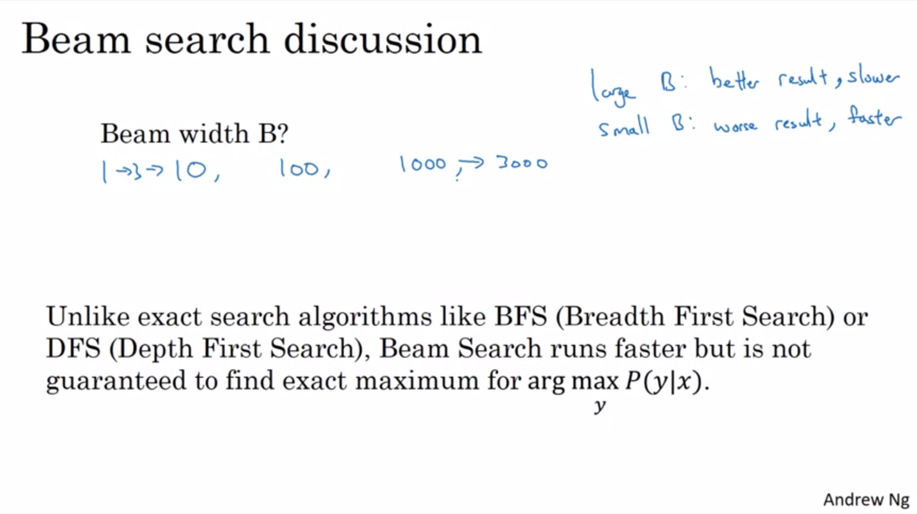

There are some implementation details to discuss.

How to choose beam width B? The larger B is the better sentences one can find but the more computationally and memory expensive it is.

In practice 3 is on the small side. In practice 10 is very common, 100 can be considered very large. In research systems people often use 1000 to 3000 to squeeze out every bit of a performance. So B is also application dependent.

Usually there are diminishing returns the larger the beam width gets. 1k -> 3k doesn’t lead to much improvement anymore.

Beam search is a widely used algorithm in many production and commercial systems.

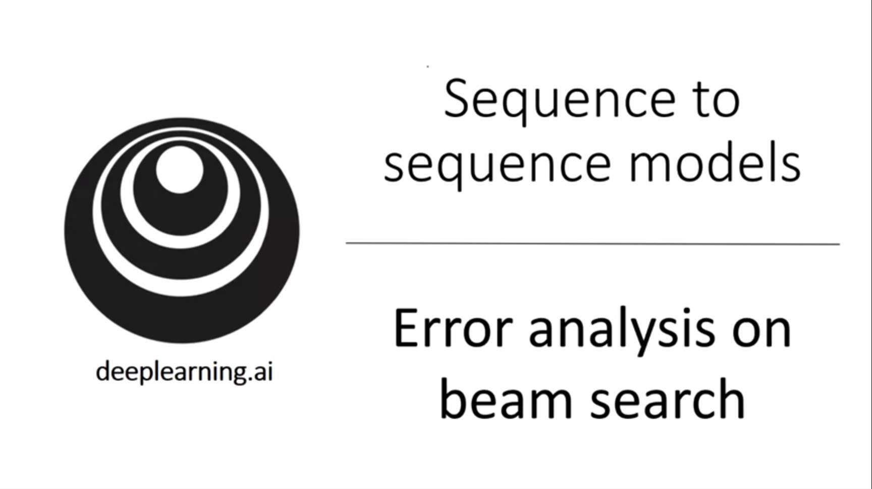

Error analysis on beam search is very common to decide whether to improve the searching algorithm. In the 3rd course of the specialization we have already seen how error analysis can help to focus the time on the most useful work for the project.

Beam search is an approximate search algorithm (heuristic search algorithm) so it doesn’t always output the most likely sentence.

What if beam search makes a mistake? We will look at how we can figure out whether the beam search algorithm or the RNN model is causing errors and therefore needs improvement.

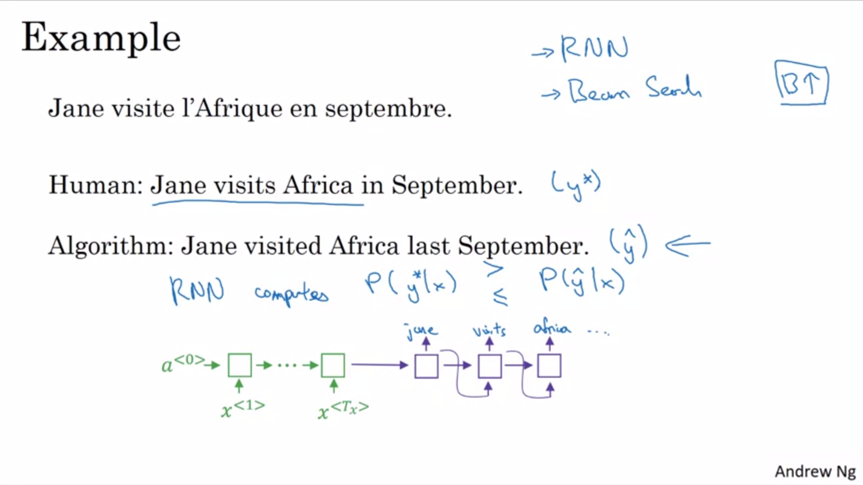

y*: pretty good translation by a human.

y_hat: translation that beam search came up with. This is a much worse translation that actually changes the meaning.

The model has two main components: the neural network model (sequence to sequence model) and the beam search algorithm. Wouldn’t it be nice if we can attribute the error to one of these two components?

We have seen that it is always tempting to collect more training data. In a similar way it is also always tempting to increase the beam width. That pretty much never hurts. But same as for collecting more training data, increasing the beam width by itself might not help you go where you want to go. So how to decide what is a good use of your time? Break the error down!

Use the RNN model to compute p(y*|x) as well as p(y_hat|x) and then see which one is bigger. Depending on which case holds true we can prescribe this particular error to one of the two components.

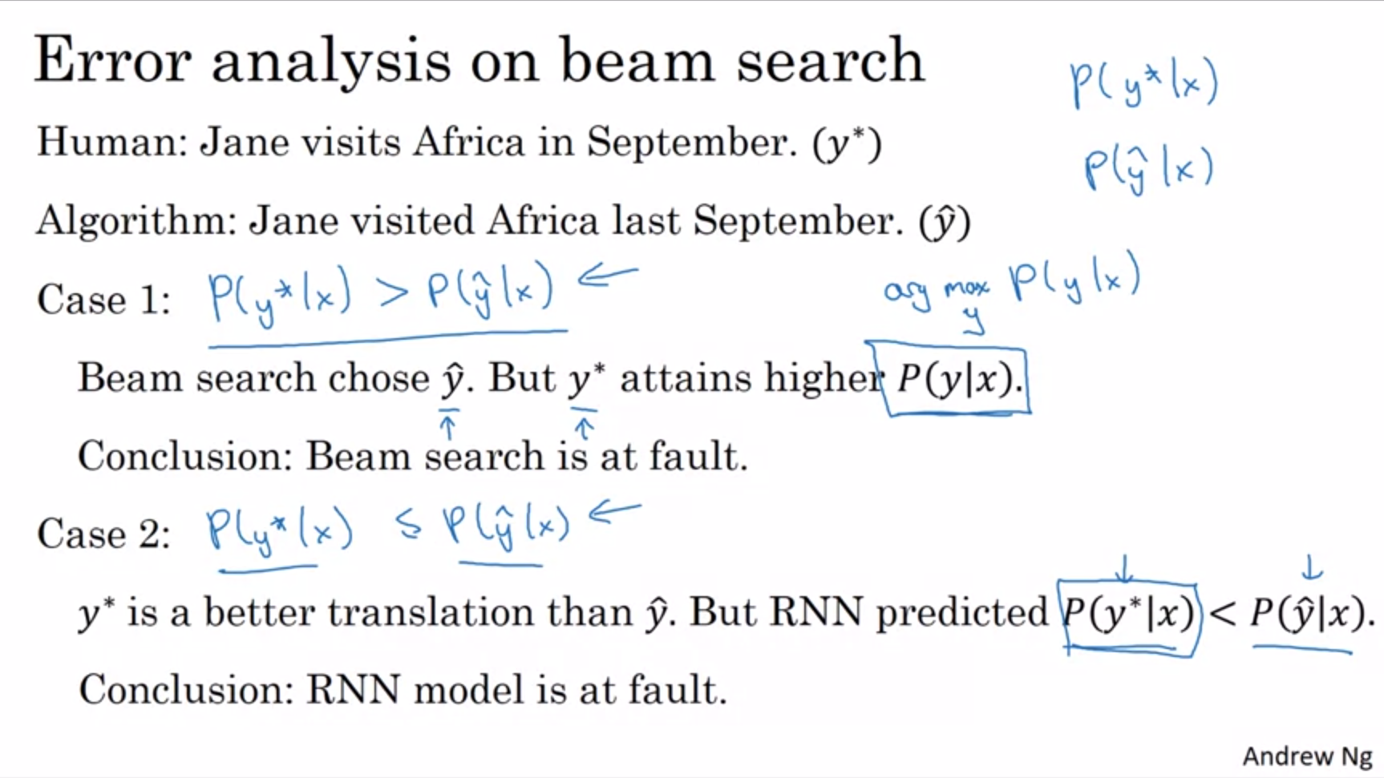

The one job of beam search is to find the value of y that maximizes P(y|x).

Either case 1 or case 2 has to hold true.

There are some subtleties pertaining to length normalization here. If we use length normalization we should use the adjusted objective function instead of the probabilities for the error analysis. Ignoring that complication here.

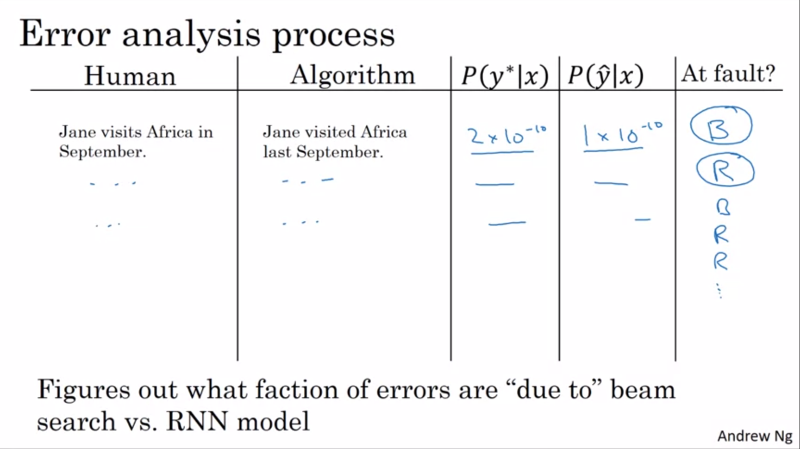

For the complete error analysis process we go through the dev set and find the mistakes and prescribe the error to the respective component.

Only if we find that beam search is responsible for a lot of errors we might want to change the beam width. Otherwise we might have to change the RNN, e.g. change regularization, get more training data, try a different network architecture etc (see course 3 for techniques applicable here).

Error analysis is very useful for approximative optimization algorithms.

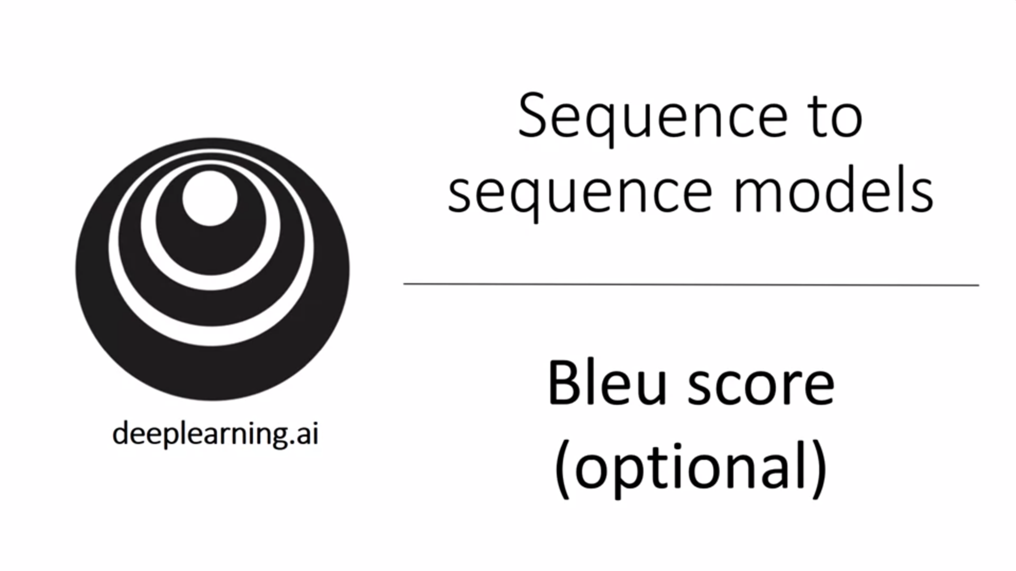

One of the challenges of machine translation is that given a French sentence there could be multiple English translations that are equally good translations. How to evaluate a machine translation system? This is not as easy as evaluating for example an image recognition system where there is just 1 right answer.

Conventionally this is done using the Bleu score.

Basically: if there are multiple great answers how do you measure accuracy?

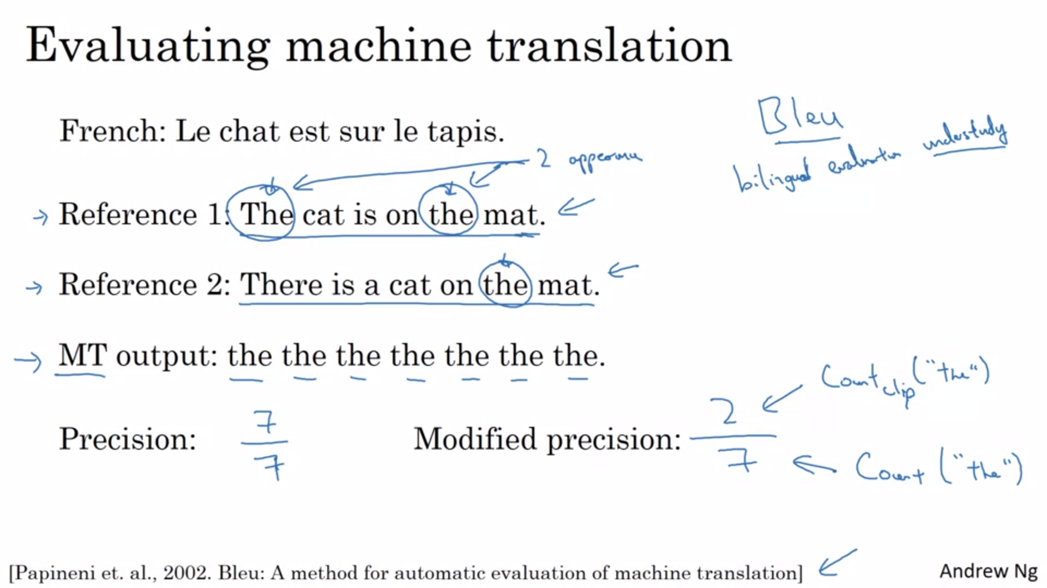

Different humans might translate this sentence in different ways.

Given a machine generated translation the Bleu score allows us to measure how good that machine generated translation is. The intuition is that if the machine generated translation is close enough to any of the references provided by humans then it would get a high Bleu score.

Bleu: bilingual evaluation understudy (in the theatre world an understudy is someone who learns the role of a more senior actor so they can take over that role if necessary).

The motivation for blue is that whereas we could ask human evaluators to evaluate a machine generated translation the bleu score can act as an understudy to evaluate every output of a machine translation system.

The blue score was due to the paper mentioned on the slide. It was very influential and is quite readable.

Do the types of words that the machine outputs appear in one of the human references that are provided as part of the dev and test set?

MT output -> machine translation output.

One way to measure is to see whether each word occurred in the references. This is called precision.

The basic precision measure is not a particularly useful measure here. E.g. “the the the…” achieves a good precision but is not a good translation.

We will use a modified precision measure instead. We will give each word credit only up to the max number of times it appears in the reference sentences (e.g. here twice in the first reference).

The denominator is the count of the number of times the word “the” appears. The numerator is clipped to 2.

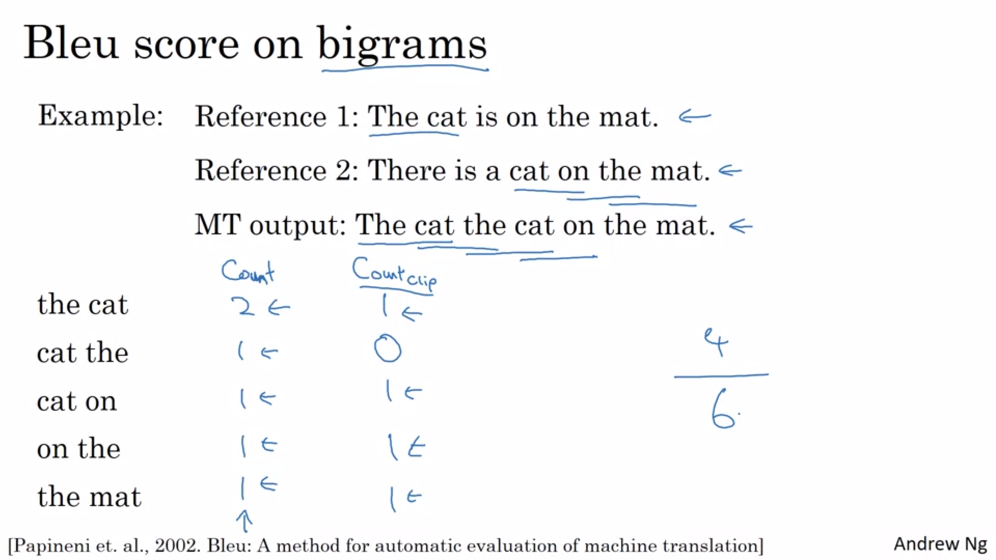

We want to look at pairs of words, not only individual words. We can calculate the bleu score on bigrams. This will be a portion of the final bleu score. We take unigrams as well as bigrams into account, maybe even longer sequences such as trigrams.

Countclip: give our algorithm credit only for the maximum number of times that the bigram appears either in reference 1 or 2.

Finally, the modified bigram precision will be the sum of the countclips divided by the total number of bigrams.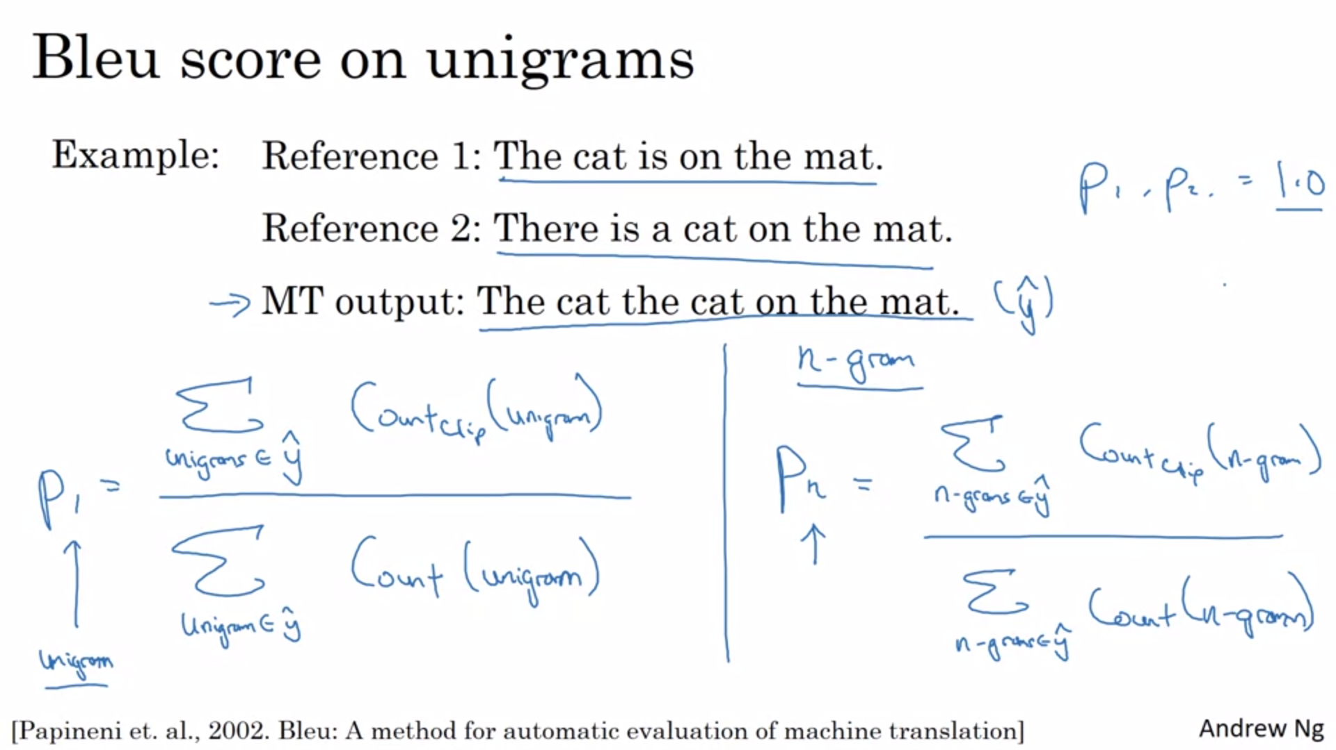

Modified precision on unigrams on the left. Modified precision on n-grams on the right. These modified precision scores allow us to measure the degree to which the machine translation output overlaps with the references.

If the MT output is exactly the same as either reference 1 or reference 2 then all of these values will be equal to 1.0. Sometimes it is possible to achieve this even if the MT output is not exactly the same as one reference.

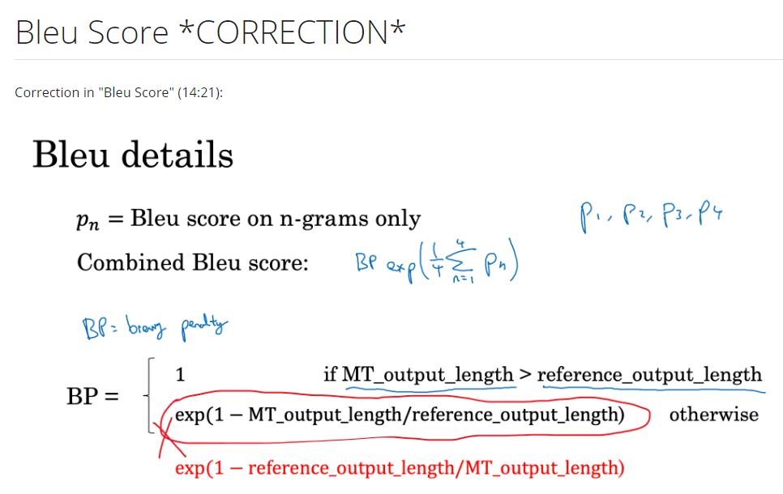

Finally put this together to form the final bleu score. Calculate the average over all individual scores and use that as argument to the exponentiation function. The exponentiation function is a strictly monotonically increasing operation. Adjust this with one more factor called the BP (brevity penalty) because it turns out that it is easier to achieve high precision with very short outputs. We do not want translations that are very short. The BP factor penalizes shorter translations.

Earlier we saw the importance to have a single value evaluation metric.

The reason why the bleu score was revolutionary for machine translation was because it gave a pretty good single value evaluation metric for machine translation.

In practice few people implement the bleu score from scratch. There are open source implementations.

The bleu score today is used for many systems that generate text such as machine translation but also image captioning systems.

The bleu score is a useful single value evaluation metric whenever you want your algorithm to generate text and you want to see whether it has similar meaning as a reference piece of text generated by humans.

It is not used for speech recognition as there is usually one specific groundtruth (instead of many that are equally good).

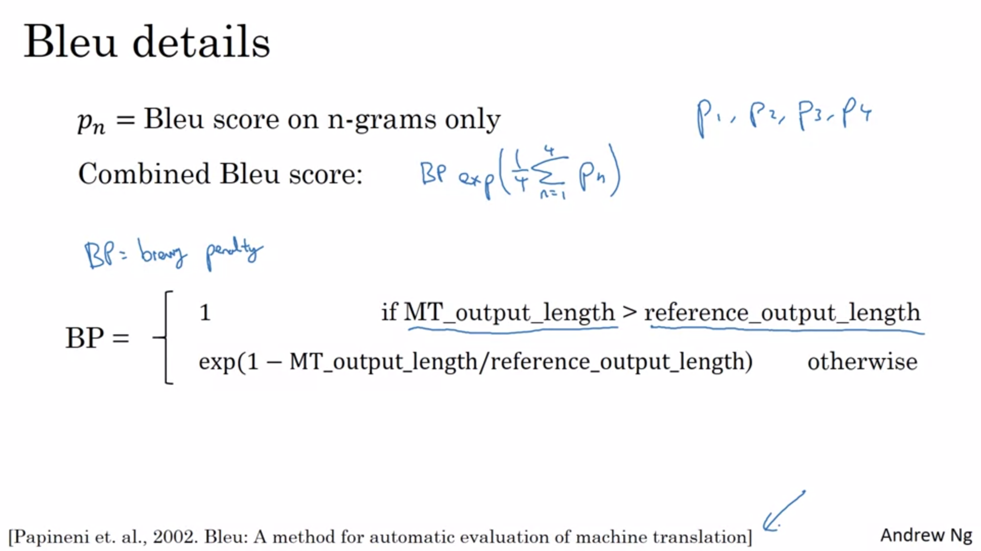

It is important to have a single number evaluation metric.

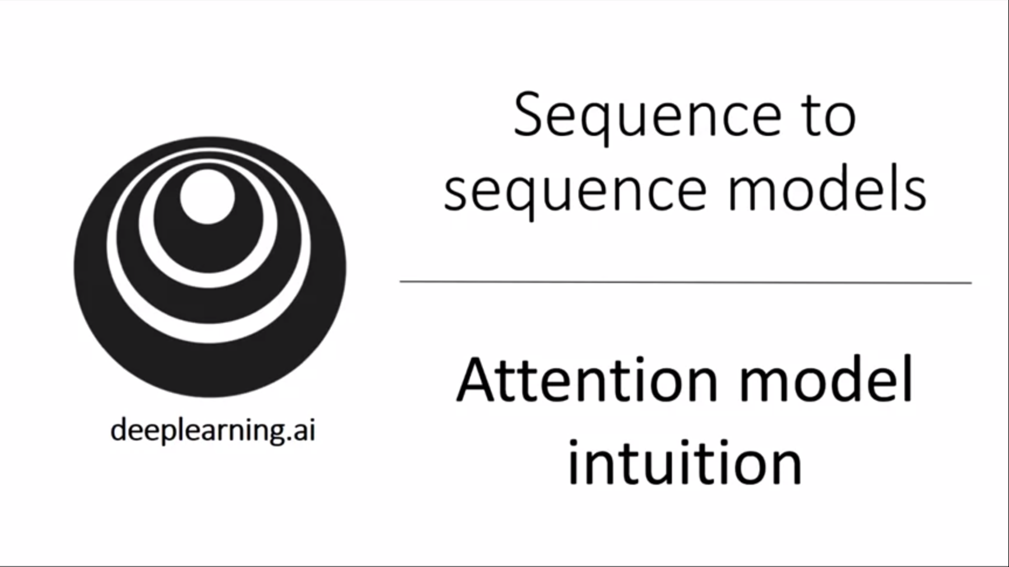

For most of this week we have been using an encoder decoder architecture for machine translation.

A modification to this is the attention model that makes all this work much better. The attention idea has been one of the most influential ones in deep learning.

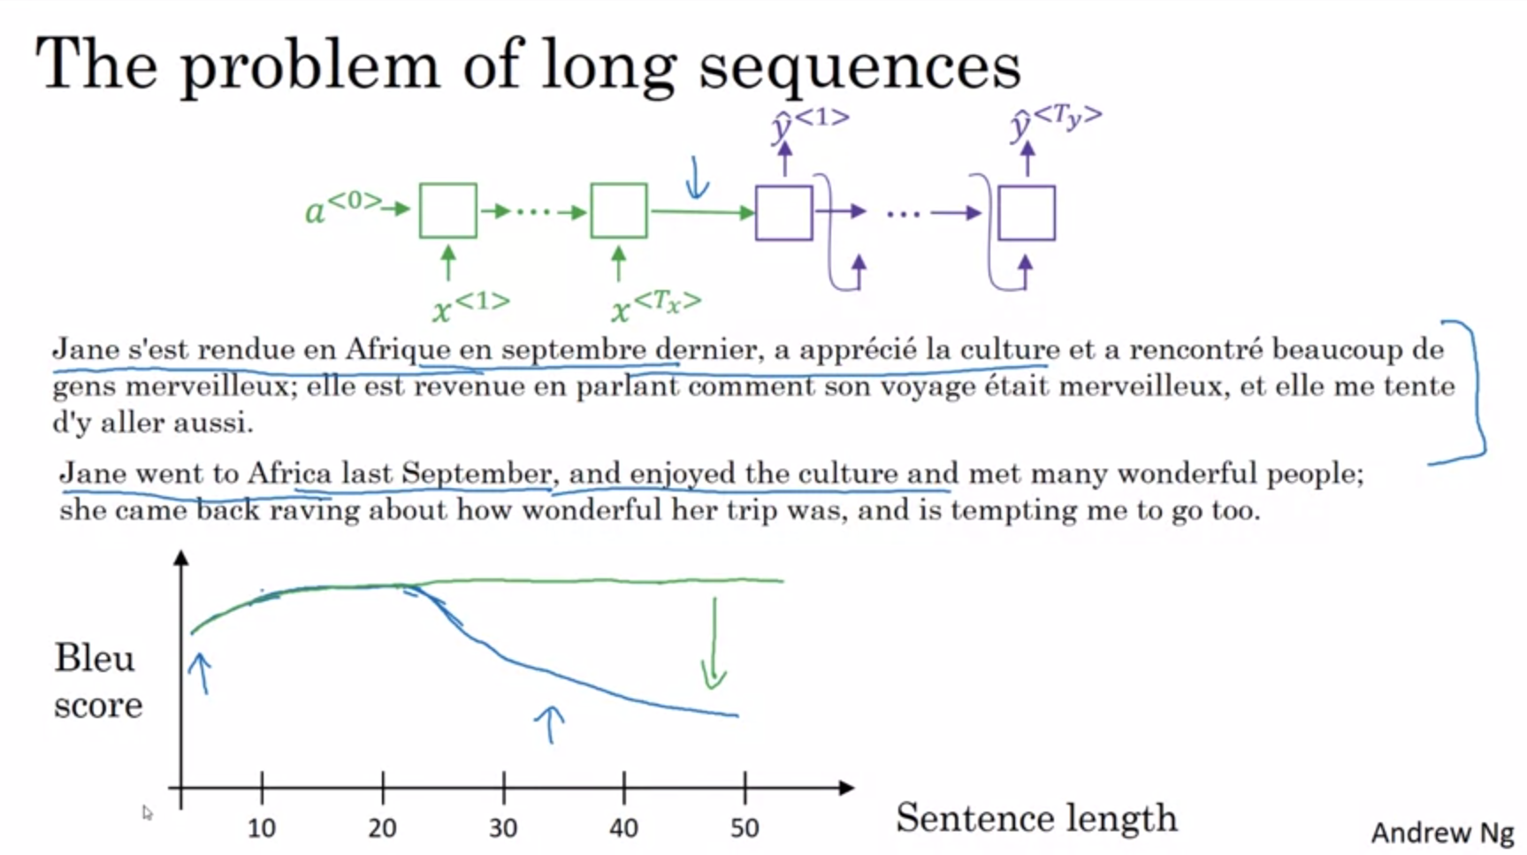

With the encoder decoder architecture we are asking the network to memorize the whole input sentence and store the activations before creating the output sequence.

Analogy to human translator. A human translator would not do this. Instead a human translator would read the first part of it and start with the first piece of translation, then read a bit more and continue to translate part by part. It is really hard to memorize the whole input sequence.

Encoder decoder architecture works quite well for short sentences but for very long sentences the performance degrades. It is difficult to get a neural network to memorize very long sentences.

The attention model translates a bit more as humans might.

Attention models can achieve good scores for long sequences (we do not see the dip in the curve).

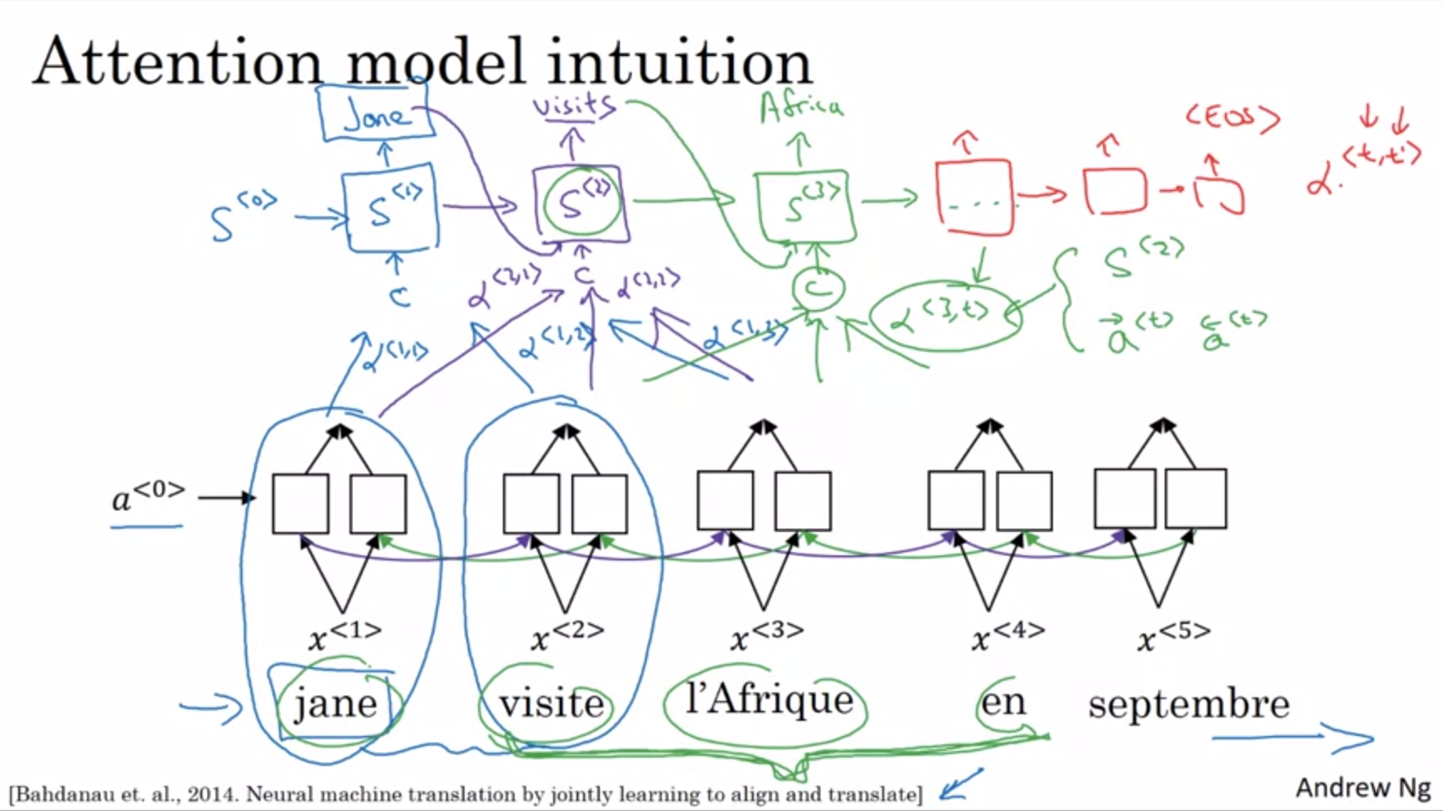

Attention model due to the paper mentioned on the slide.

It was originally developed for machine translation but has spread to many different applications. It is really a very influential seminal paper in the deep learning literature.

Let’s first illustrate the idea with a short sentence although the algorithm was developed for long sequences. We start with a bidirectional RNN in order to compute some set of features for the input word. We get rid of the y’s on top. We will use another RNN to generate the English translation (top of the slide). In order to avoid confusion with first RNN we denote activations as s.

The question is when we are trying to generate the first word output (“jane”) what parts of the input French sentence should we be looking at? It seems primarily the first word but not the end of the sentence.

We will compute a set of attention weights alpha.

Alpha<1,1>: when generating the first word how much attention should we pay to the first piece of the input?

Alpha<1,2>: when generating the first word how much attention should we pay to the second piece of the input?

And so on…

The alphas will tell us the context to which we should pay attention to. This will be input to the upper RNN (c for context).

For the second output we will have a new set of attention weights and so on…

How exactly is the context defined? This we will have a look at next. Also how to compute the attention weights.

The attention depends on the activation of the bidirectional RNN (forward activations and backward activations) as well as the state from the previous step s. Details will be discussed next.

Key intuition to take away: the RNN marches forward generating one word at a time until it eventually generates <EOS>. For each step we have the attention weights alpha that tell it when generating the tth English word how much attention to pay to the t’th French word.

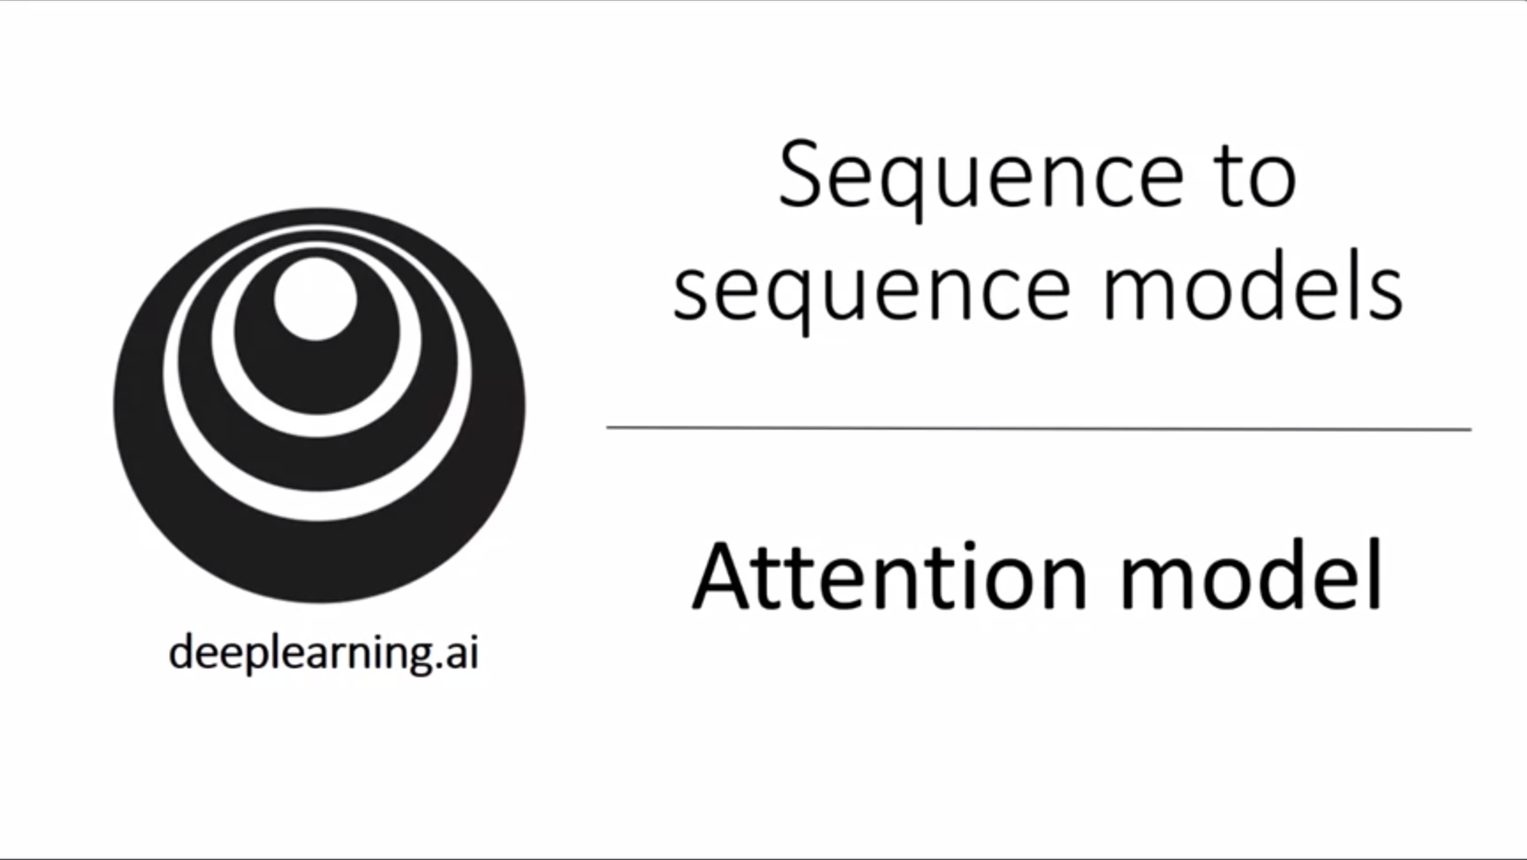

Now we fetch out the details of the attention model.

We have seen how the attention model allows us to pay attention to only part of the input when generating a specific output (much like a human translator).

Let’s now formalize the intuition into the exact implementation details.

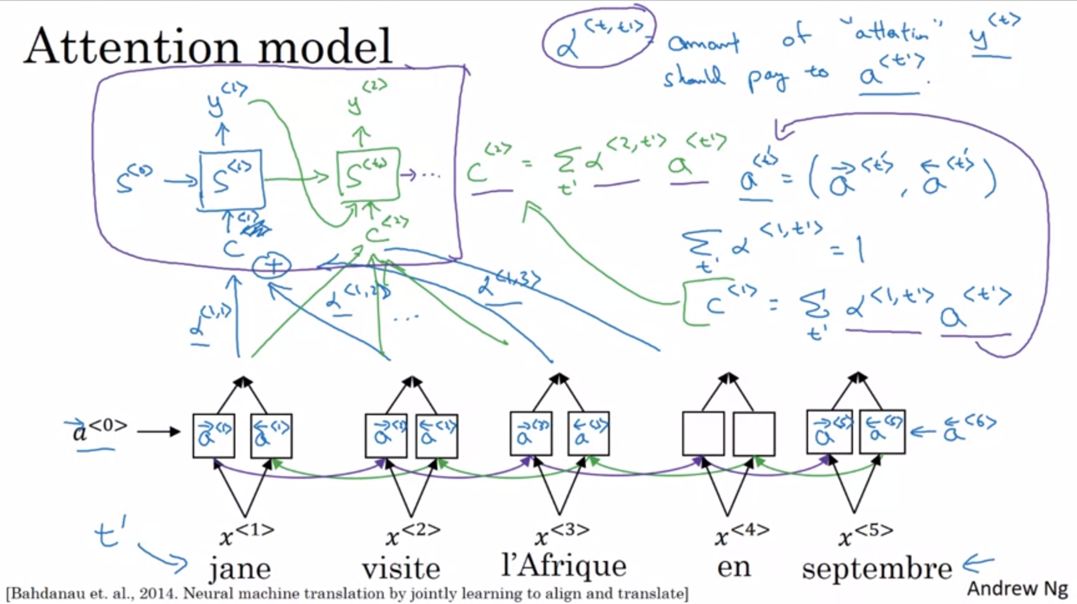

Let’s assume same input sentence as in the previous video.

We use a bidirectional RNN/GRU/LSTM to compute features for every word. In practice LSTMs are most common. First compute forward and backward activations. a<0> and a<6> are vectors of all 0s.

a<t’> will represent the concatenation of the forward and backward activations and will be our feature vector for timestep t’.

We have a forward only RNN with state s to generate the translation. The first timestep will generate y<1>. This will have as input some context c<1> (also written as just c). This will depend on the attention parameters alpha. The alpha parameters tell us how much the context will depend on the features / activations that we are getting from different timesteps.

The context will be a weighted sum of the features from the different timesteps weighted by these attention weights. The attention weights will sum up to 1.

The next timestep will be similar. Now we have a new set of attention weights and a new weighted sum will be calculated.

Using the context vectors as input, the upper RNN looks like a quite standard sequence model that generates the output translation one word at a time -> “post-attention RNN”.

We have also defined how to compute the context vectors. The only remaining thing to do is to define how to compute the attention weights.

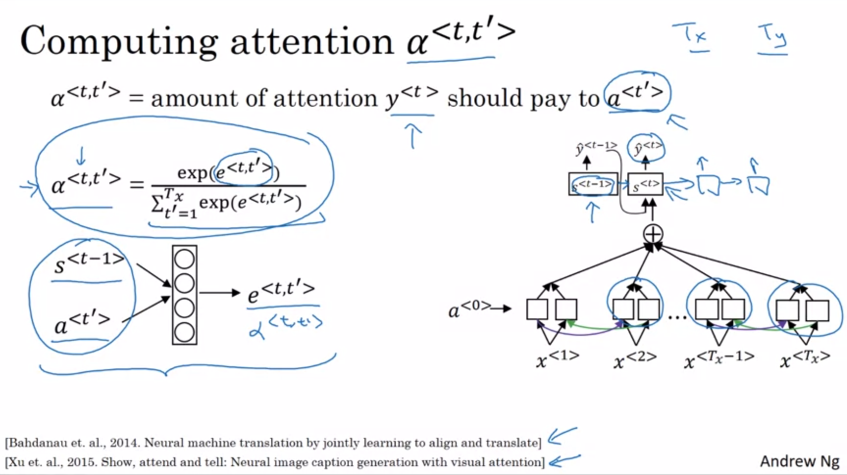

A softmax is used to make sure that attention weights sum up to 1.

How to compute factors e? One way to do so is to use a small neural network as shown on the left of the slide. It is usually a 1-layer neural network for computational efficiency.

The hidden state from the previous step is one input. The other input is the feature vector from timestep t’ The intuition is that if you want to decide how much attention to pay to the activation of t’, the things that it seems it should depend the most on is the own hidden state activation from the previous timestep (we do not have the current state activation yet) and then look at the features from the input of that particular timestep. So alpha<t,t’> and e<t,t’> will depend on these two quantities.

Since we do not know what exactly the function is we will just train a very small neural network and trust backpropagation and gradient descent.

The whole network will then pay attention to the right parts of the input that are relevant for its output prediction (automatically with gradient descent).

One problem with this algorithm is that it takes quadratic time / cost to run. The total number of attention weights will be Tx * Ty.

For machine translation quadratic cost is ok since neither input nor output are too long.

There is some research work trying to reduce this cost.

So far we have seen the attention idea in machine translation. This idea has been applied to other problems as well such as image captioning (like the paper on the bottom of the slide). In this paper the authors show that with a similar architecture we can look at a picture and only pay attention to parts of a picture to write an image caption.

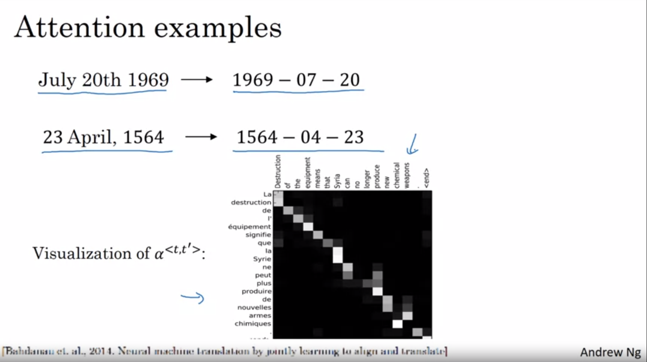

Machine translation is a very complex problem. Attention can also be used for date normalization -> normalizing dates of different formats into a standard format.

What is also fun to do is to look at the visualizations of the attention vectors.

Attention weights between the corresponding input and output words tend to be high, thus suggesting that when generating a specific word in the output the network is usually paying attention to the correct word in the input. All this attention was learned using backpropagation.

This is one of the most powerful ideas in deep learning.